Good morning!! I hope all is well!! It is super stay at home week 4 (I think, it all blends together)!

Before break we were dealing with taxonomy and cladograms. I will get all of that graded this week, but am waiting to hear about grades and procedures in a meeting on Monday. In looking at your cladograms they all looked pretty good. The finished product should have looked like:

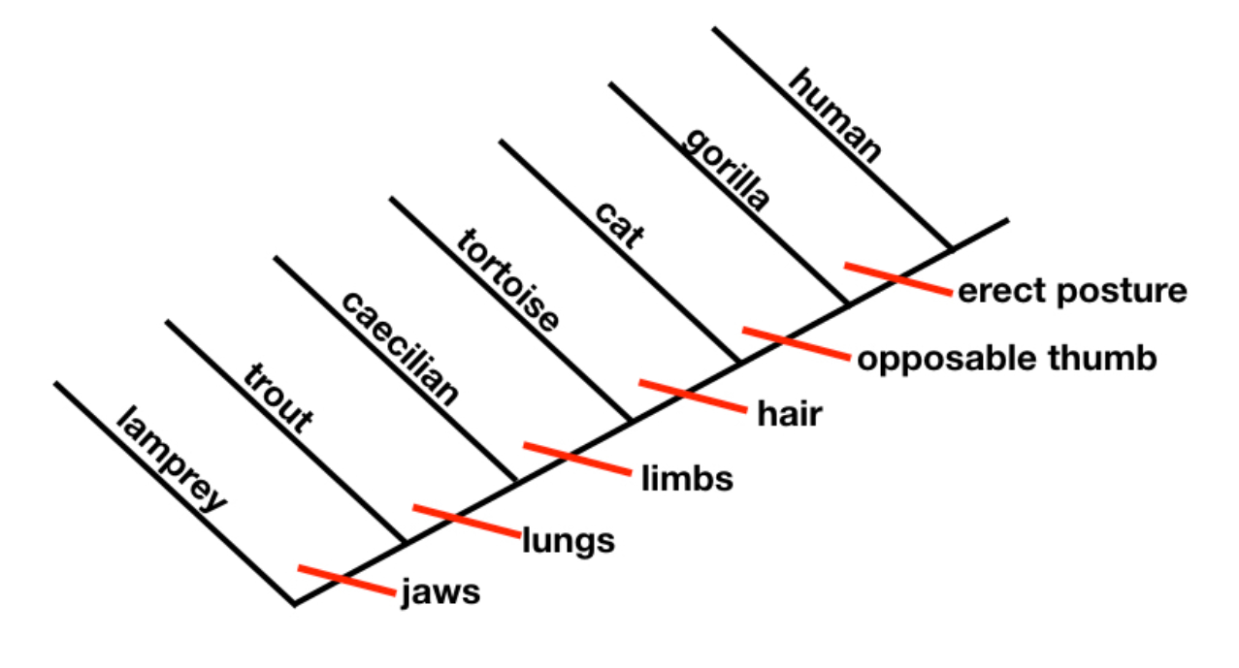

If yours is not perfect, do not fret. We are all working to figure out this remote learning stuff.

In order to facilitate this, I will be holding zoom conferencing sessions Tuesday and Thursday at 10am. The code for these is 233-612-517. If you are not already familiar with this, you will be soon!

This week we are learning something a bit simpler. We are doing the last unit we would have needed before the EOC (which is obviously not happening), Ecology. Some of this ecology stuff is simple review and we did some brief parts I know, but it is on our standards and since we have extra time let’s go a little more in depth. This week is a lot more informational while next week we will have a small project based on these chapters.

The first I want us to try and do is access the online book.

<https://www.pearsonrealize.com/index.html#/>

**Student log in info:**

U/first initial+lastinitial+studentID#+@psn (example: lw123456@psn)

P/Fairfield#1 (students can change their password if they wish)

If you are unable to login please let me know. After this week I might try assigning some things in the text.

The other assignments this week should be relatively straight forward. I will be talking about chapter 3 and 4 on Tuesday and Chapter 5 on Thursday.

If you have any questions, obviously reach out. Otherwise work hard and stay healthy!!