QUICK LAB
Construct a Cladogram
You can think of a cladogram as an evolutionary family tree in which things that are more closely related share more characteristics. As an analogy, processes that have evolved due to new technologies can be organized using cladistics. In this lab you, will fill in a cladogram for methods of transportation.
Problem
How can methods of transportation be organized using a cladogram?
PROCESS SKILLS
Classifying
Procedure
1. Complete the cladogram:

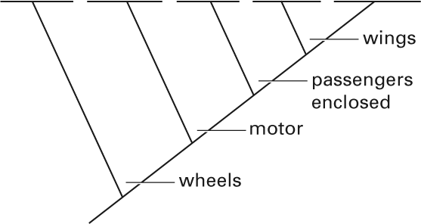
2. Think about the characteristics of the following methods of transportation: bicycle, car, motorcycle, airplane, and on foot.
3. Complete your cladogram by filling in each method of transportation listed in step 2 on the appropriate line at the top.
Analyze and Conclude
1. Identify What "derived characters" are used in this cladogram?

2. Analyze Which mode of transportation may be considered an "outgroup"—a group that has none of the characteristics labeled on the cladogram?

Construct a Cladogram continued
3. Make an Analogy A species that has evolved a new trait is not better than a species without that trait. Each species is just adapted to a certain way of life. When might riding a bike have an advantage over flying in an airplane?

