Good morning!! I hope all is well!! It is super stay at home week 4 (I think, it all blends together)!

Before break we were dealing with nuclear chemistry. I will get all of that graded this week, but am waiting to hear about grades and procedures in a meeting on Monday. The biggest things to take away from that unit are the immense amounts of energy that come from nuclear reactions (e=mc2), and what fission and fusion are.

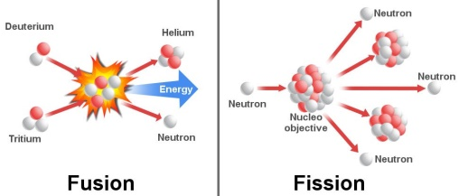

If you don’t understand everything, do not fret. We are all working to figure out this remote learning stuff.

In order to facilitate this, I will be holding zoom conferencing sessions Tuesday and Thursday at 1pm. The code for these is 343-081-360. If you are not already familiar with this, you will be soon!

This week we are learning something a bit simpler (I hope!). We are switching over to astronomy. Astronomy is a topic lots of students typically enjoy and there are also a lot of resources for. The thing to understand about astronomy is that it uses a lot of the science we have learned as how the universe works is all physics and chemistry. It will take us several weeks to get through as we start close and move further and further out. My basic plans for the next few weeks are:

Week 1 –Planets and Solar System

Week 2 – Stars and Galaxies

Week 3 – Hubble and Big Bang

Week 4 – Project and assessment

This week we are looking at the things closest to us, the sun and planets. We need to understand a few things about them and then look at how we think they formed. You have some videos and readings to help understand these things. In our live sessions, I will be talking about planets on Tuesday and the formation of the solar system on Thursday.

If you have any questions, obviously reach out. Otherwise work hard and stay healthy!!